PRIME WATER

The Industry Leader in Alkaline Water Ionizer Technology

PREMIUM ALKALINE WATER IONIZER
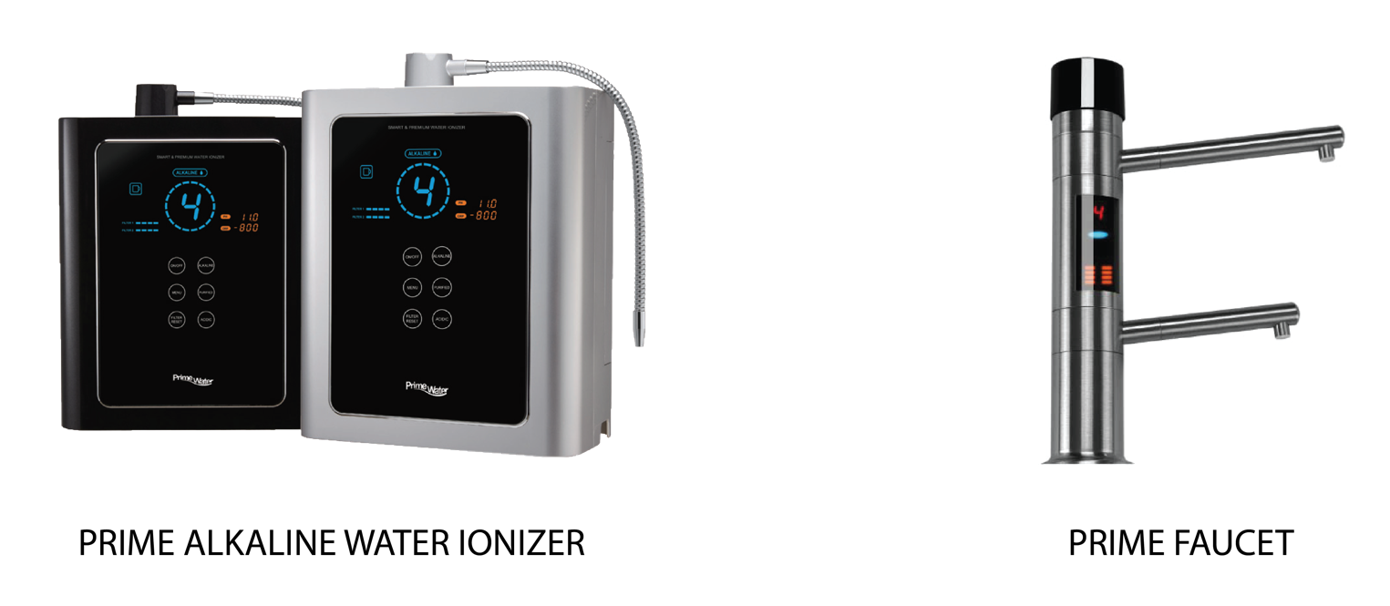

Product Features
- Premium Alkaline Water Ionizer
- Max large 9/11/13 plates with higher performance.
- 99.99+ Platinum coated Titanium plates.
- Titanium mesh plates design increased 30% surface area.
- Up to -800mV Oxidation Reduction Potential (ORP).
- Latest generation SMPS power supply with Super Cooling System* provide better efficiency and durability.
- Alkaline water pH range from 8.5-11.0.
- Dual multistage filters keep your water clean and fresh.
- Medical device certified by Korean Food and Drug Administration (KFDA).
- Audio comes with 8 different languages.
- Auto diagnosis system helps to monitor the internal operation of ionizer.
- User friendly Smart Touch Panel.
- ISO 9001 and ISO 14001 certified.
- Compact sleek new design that complements the look of your kitchen.
*Only for Prime 1101-R and 1301-R model.
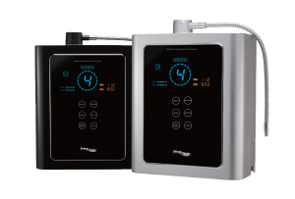

POWERFUL PERFORMANCE 9 OR 11 PLATES ELECTROLYSIS SYSTEM
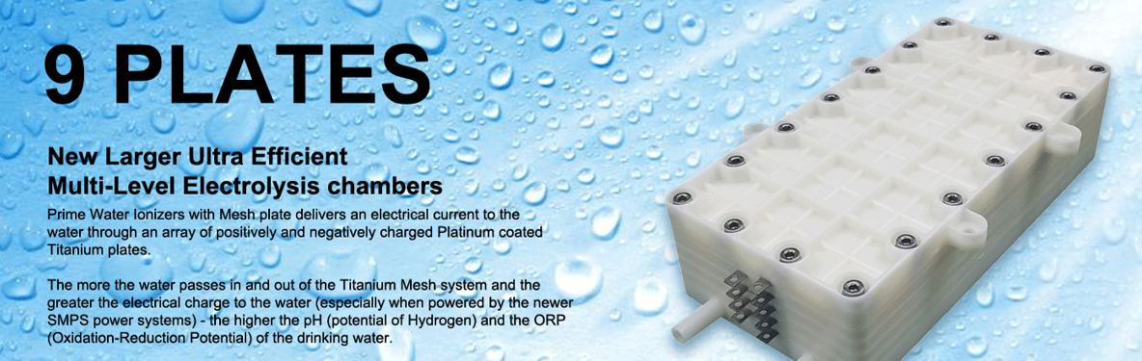

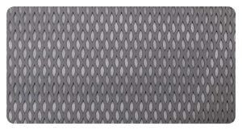Plates Automatic Cleaning System
Automatically initiates a cleaning cycle after each use, so you don't have to wait for any inconvenient cleaning discharge cycles.
Platinum Titanium MESH Plate (125 X 60mm)
135,000mm & 209.01 square inches

POWERFUL SMPS POWER SYSTEM
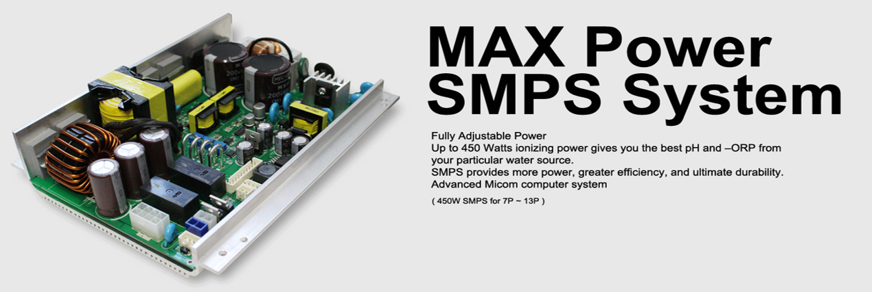
POWERFUL SMPS POWER SYSTEM is the most advanced system on the market to insure that your water ionizer is producing the most powerful ionized water for years and years to come. Unlike the old outdated transformers, the SMPS system has been shown to last longer and run cooler. With the most up to date technology, you’ll never have to worry about the pH or ORP levels of your water ionizer.
PREMIUM DUAL FILTRATION SYSTEM
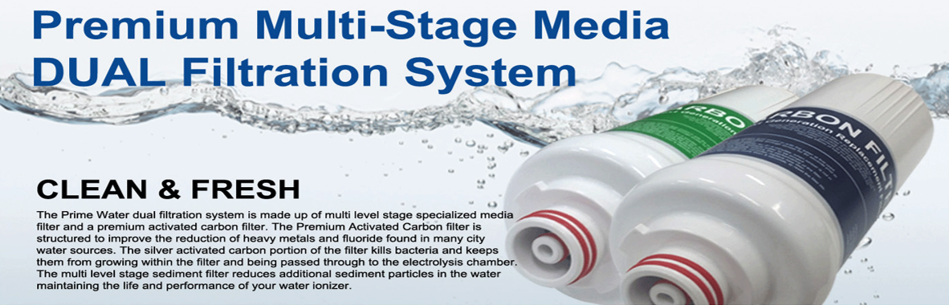
Premium Multi-Stage Media ULTRA DUAL Filtration System
The Prime 901-R/ 1101-R dual filtration system is made up of multi level stage specialized media filter and a premium activated carbon filter. The Premium Activated Carbon filter is structured to improve the reduction of heavy metals and fluoride found in many city water sources. The silver activated carbon portion of the filter kills bacteria and keeps them from growing within the filter and being passed through to the electrolysis chamber. The multi level stage sediment filter reduces additional sediment particles in the water maintaining the life and performance of your water ionizer.

Prime Water Alkaline Water Ionizer Specifications

General Specifications
Product type | Alkaline Water Ionizer | Alkaline Water Ionizer
Model Name | PRIME 901-R | PRIME 1101-R
Dimensions | 33cm X 34.7cm X 15cm | 33cm X 34.7cm X 15cm
Unit Weight | 6.5kg | 6.5kg
Maximum Water Supply Pressure | 50psi | 50psi
Applicable Water Temperature | 5-30 °C | 5-30 °C
Electrolysis Method | Continuous Electrolysis | Continuous Electrolysis
Cleaning Method | Automatic & Manual | Automatic & Manual
Plate Materials | Platinum Titanium | Platinum Titanium
Plate Number | 9 | 11
Plate Type | Flat or Mesh (Optional) | Flat or Mesh (Optional)
Flow Control | Automatic | Automatic
Alkaline Setting | 1-2-3-4 | 1-2-3-4
Acidic Setting | 1-2-3 | 1-2-3
Purified setting | 1 | 1
Ionized Water output rate | Max 3 liters/ 1 min | Max 3 liters/ 1 min

Electrical Specifications
Rated Voltage | 110V or 220V
Power Consumption | 450W
Power Supply Device | SMPS
Display | Full colour LED
Control Button Type | Touch Button
Filter Life Indicator | FND Number Indicator

Water Filter Specifications
Filter Number | 2 Filters (Dual filtration system)
Filter Replacement | Cartridge
Filter Life | 6 months (20 Liters/day)
Composition | Activated carbon, sediment filter, fiber filter, ceramic ball

PRIME FAUCET

(Optional)
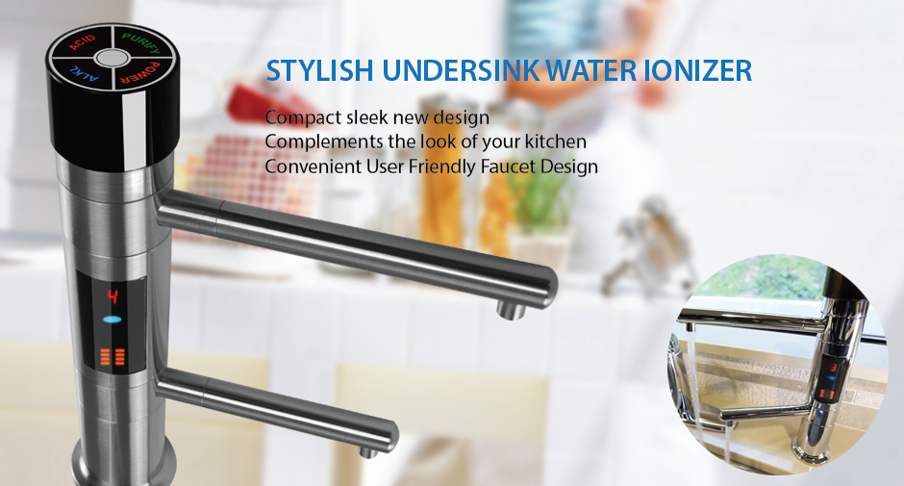
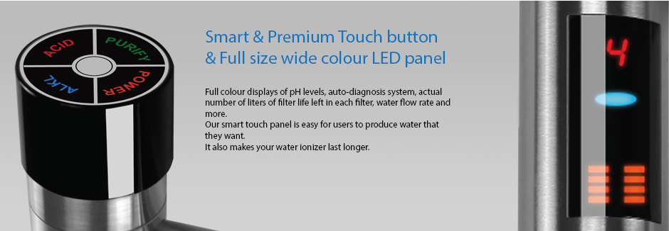
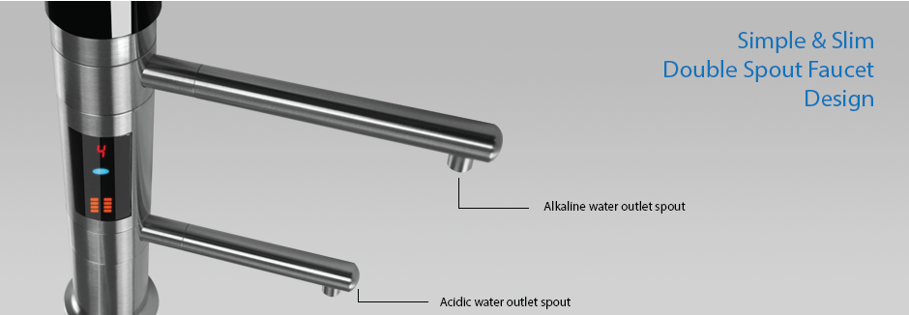

Prime Faucet Specifications
Product type | Alkaline Water Ionizer
Model Name | PRIME FAUCET
Dimensions | 25.5cm X 30cm X 45cm
Unit Weight | 1.5kg
Maximum Water Supply Pressure | 50psi
Applicable Water Temperature | 5-30°C
Display | Full Colour LED
Filter Life Indicator | Bar Graphic Type
Spout length (Long) | 14cm
Spout length (Short) | 11cm
Faucet Height | 25.5cm
Flow Control | Automatic
Alkaline Setting | 1-2-3-4
Acidic Setting | 1-2-3
Purified Setting | 1
Ionized Water Output Rate | Max 3 liters/ 1 min

Product pH and ORP Values
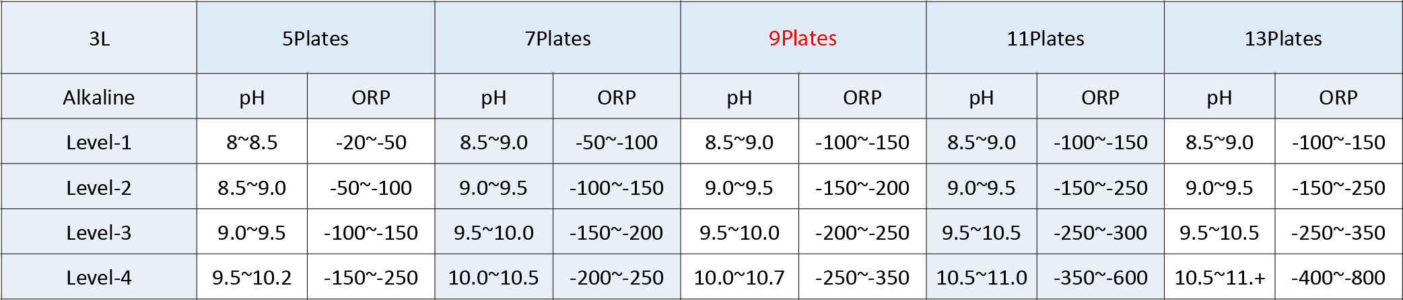
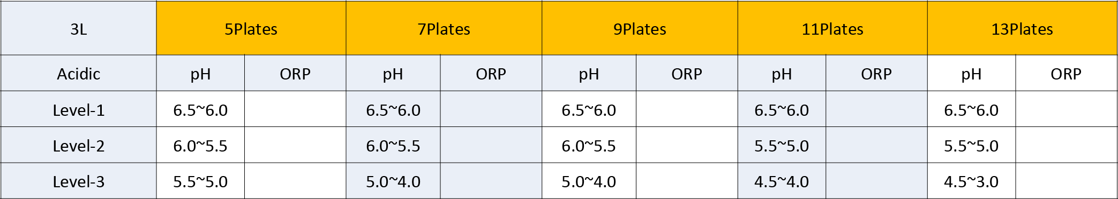

Certificates
